Ou QTCP: Adaptive Congestion Control with Reinforcement Learning

1 INTRODUCTION
Despite effortexpended to develop new congestion control protocols (such as Vegas, FAST, see Sec. 6 for more details), these protocols broadly share a common limitation of not being able to perform well across a wide range of networking scenarios, and hence, are seldom deployed in real world networks.

Tudo isso por causa de regras pré-configuradas, daí faz-se necessária a adaptação

Mais uma vez, Reinforcement Learning (RL), Q-learning – mudando a política de forma on line, é um diferencial

Specifically, QTCP
continuously updates the values of possible state-action pairs of
the protocol, based on the measurement of performance metrics
collected from a networking environment, and uses Q-learning
algorithm to search for the best action, i.e., how to adjust the cwnd
in specific states so that the long term reward of the sender is
maximized.

Desafios – elevada dimensão do espaço, o que pode tornar a tabela estadoXação muito grande, o que requer muito tempo de treimamento.

Daí se utiliza uma função de aproximação Kanerva coding ou Sparse Distributed Memories (SDMs)

2 BACKGROUND AND MOTIVATION

2.1 Congestion Control: Problems and a Classical Solution

AIMD do NewReno

2.2 Limitation of Rule-based TCP Protocols
Incapacidade de se adaptar a cenários de rede imprevistos
Incapacidade de se aprender com o histórico da rede: Cada início de conexão é iniciado uma sondagem. No caso do newReno sempre começando com o SlowStart

Simulação de uma conexão NewReno em um enlace semelhante a de um Rádio Cognitivo que chaveia ente frequências e, por conseguinte, entre bandas. O NewReno nunca consegue aproveitar a capacidade do enlace, por dois motivos princiapais:
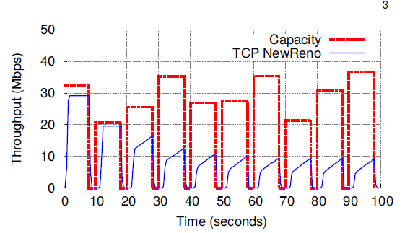

1)Timeout durante o chaveamento
2)Reiniício do Congestion Avoidance do zero a cada chaveamento

3 QTCP:APPLY Q-LEARNING TO TCP CONGESTION CONTROL

3.1 Overview of QTCP
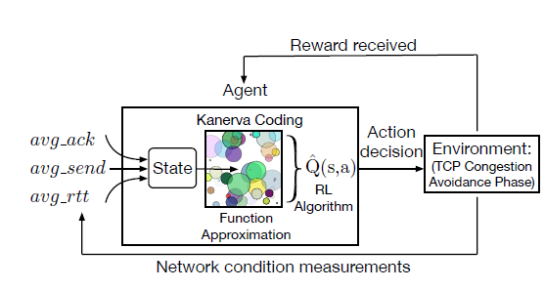

Utilização do Q-learnin e de uma técnica de redução de espaço para viabilizar o RL

3.2 States
Mesmas do Remy

For example, avg_send characterizes the
traffic sending rate at the sender side and avg_ack reflects the real
goodput measured at the receiver side. If there is no congestion,
then ideally avg_send should be equal with avg_ack. On the
other hand, avg_send < avg_ack indicates a high possibility of
congestion and the sender should slow down its sending rate.

Veja que mesmo assim o espaço de estadoe é grande
Note that although we reduce the number of state variables to
three, the state space is still huge because of the large number of
different values these variables can take. For example, assuming
the range for avg_ack and avg_send is from 1 to 175 and the
range for avg_rtt is from 120 to 155, then there will be a space of
1, 115, 136 states. Such a large space poses a great challenge to
the design of QTCP, as it can make the learning process very slow
and could make convergence impossible. We will further discuss
this problem in Sec. 4.

3.3 Actions
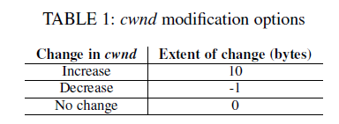

10 para rapidamente aproveitar
Diferença para os NewRenos like é que ass muidanças não são em função dos ACKs, mas
em função do agente, ao tomar uma ação, a cada t_{interval}

3.4 Utility Function and Reward Definition

Utilizar a diferença entre as funções de utilidade, para perceber melhor o ganho/perda
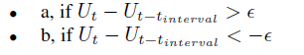

Tem que “passar” de ε para tomar uma ação!

4 PRACTICAL QTCP WITH FUNCTION APPROXIMATION
Contornando o problema do espaço de estados grande
This approach starts with an initial set
of randomly selected prototypes and periodically deletes poorlyperforming/
rarely utilized prototypes and generates corresponding
new prototypes (e.g., ones that are adjacent to most frequently
utilized prototypes) to gradually adjust the allocation of original
set of prototypes to cover the region of interest

Se utiliza do TCP tradicionais
our learning process can be interrupted in
certain situations that are handled by standard TCP mechanism
such as slow start and fast recovery

5 EVALUATION
5.1 Experimental Setup
We focus the comparison of following three approaches:
dumbbell-like com experimentos com banda fixa e variável.
• NewReno: classical and default congestion control protocol
in use today
• QTCP-Baseline: QTCP with the original adaptive Kanerva
coding algorithm, which is a state of art function
approximation method that serves as a baseline
• QTCP-Generalization: QTCP with our newly proposed
generalization-based Kanerva coding
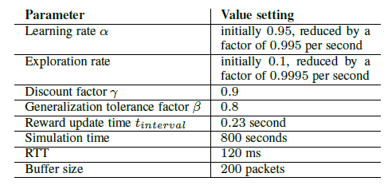

Resultados expressos em Cumulative Distribuction Function, que é a probabilidade de se atingir um determinado valor e em termos de trhoughput

Vocabulário

selrom – Rarely

stems – Caule, sustentação

overwhelming - very great in amount.

Greedily - in a way that shows an excessive desire or appetite for food.

Stall – 1. a stand, booth, or compartment for the sale of goods in a market or large covered area.
2. of a motor vehicle or its engine) stop running, typically because of an overload on the engine.

